Project 6 Report

1. Himalayan Adventurers

2. Amna Tanveer, Jacob Lemley, Nachiket Vamshidhar, Kaitlin Forsythe

3. Description:

You wake up suddenly, on an icy ground with a cold breeze gushing at you from every direction. The air is dry. You look up and there are mountain ranges surrounding you from lengths of 2,400 km. The feeling of confusion is creeping up on you; you think, "How did I get here?" A wooden board on your far left says, "Welcome to the Himalayas," but there is no one to be found. The view is beautiful yet ominous, since ice caps are melting around you, and the famous Himalayan black-necked cranes skulls are surrounding you in masses. You walk around or across the still river in hope to find someone, but you find yourself in loss of words as you see a village flooded from afar. As a UT environment student, you believe it is your responsibility to report this to the world by taking up any remaining artifacts. Also, the goal is to collect as many artifacts/details as you can. Maybe one of them can help you get home.

4. Simple User Manual:

When the program starts, the introduction is printed. Type in commands like GO <direction>, PICK UP <object>, DROP <object>, LOOK at <object>, or HELP to get a list of commands and tips. To exit, type EXIT. Your goal is to find a way out of the Himalayas using tools found throughout the map and collect valuable artifacts to pay off your student debt. Other commands not listed above might be available in certain areas.

5. Topics from the Solution Requirements List and their Location:

All lines are in “Himalayas.py” unless otherwise noted.

* Function Definition and Function Call (7) - line 258
* Function Definition with Parameters and Function Call (10) - line 162
* A function that calls another function (main not included) (5) - line 224
* Assignment Statement (3) - line 163
* 2 Styles of Comments (single and multiline) (3) - line 136
* File Reading (15) - line 27
* File Writing (15) - “secrets.py”, line 37
* If Statement (5) - line 229
* Nested If Statement (7) - line 122
* For loop (7) - line 177
* While loop (7) - line 269
* A Class (20) - line 14
* List (10) - line 29
* Dictionary (15) - line 260
* A list that contains lists (20) - line 142
* Nested Loops (12) - line 166
* Python code that “walks” through the contents of an List (or other data structure) (7) - line 172
* Using build-in List (or other data structure) functionality (so a function like insert or append) (3) - line 49
* Try/Except Block (15) - line 270
* Using +=, -=, etc (3) - “secrets.py” line 7
* Using len with a purpose (and not within a different piece of code you are getting points for) (2) - line 73
* print() statement (2) - line 127
* Using the formatting for strings (with print() statement) (5) - “secrets.py” line 31
* Random Number Generator (10) - line 241
* Import another Python file and use functionality (10) - line 3
* Flowchart or Design of the Entire Program (required) (20) - “secrets.py”, line 41

6. A flowchart or design of the entire program:

Type MAP in game to view a flowchart and other project details.

This is what the map looks like when the program returns it.

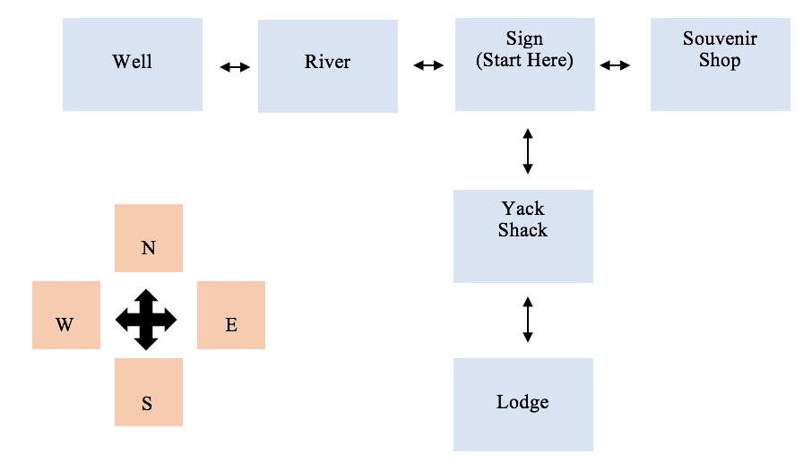

7. Any known errors or problems with your program

We had a problem sorting out inputs, where you can type “sou” and it will still register as “south”. Besides that it looks to be running okay. Try/Except blocks used throughout to stop

8. Any messages to the instructor:

We hope you enjoy our game!

<https://github.com/JacobLemley/CS_Final/graphs/contributors>